-CRST Project-

BSD5a Ranges in Progress
Business System Design

Author: Sue Leach
Date: 05/01/2006
Version: 3.0

Authority: Janet Smith (Programme Director)
Signature:

Authority: Danielle Coe (Change Manager for Merchandising and Space)
Signature:

Authority: John Wootton (Change Manager for Commercial)
Signature:

Authority: Steve Clarke (Space and Merchandising Director)
Signature:

Authority: Amanda Sawkins (Merchandising Business Project Manager)
Signature:

Contents
1. Document Change Log 4
2. Introduction 5
2.1 Background 5
2.2 Document Purpose 5
2.3 Document Scope 5
2.3.1 Requirements not met by this design 6
3. System Context 7
3.1 System Process Description 7
3.2 System Process Diagram 8
4. System Design 9
4.1 Ranges in Progress Screen Navigation 9
4.2 System Processes 10
4.2.1 Login in 10
4.2.2 Select User 10
4.2.3 View and Select Ranges 10
4.2.4 Send Ranges to Merchandising Systems 30
4.2.5 Reconcile Ranges and Plans 31
4.2.6 Reject Range 43
4.2.7 Authorise Ranges 45
4.2.8 Maintain Settings 55
4.3 Audit Trail 57
4.4 Management Information Reports 58
4.4.1 Authorisation Report 58
4.5 Security/Access 66
5. Appendices 70
5.1 Range Status 70
Change Record 71
Associated Documents 71

Document Change Log
Version 2.1 – 3.0
Section | Amendment
4.2.7 | Removed the requirement to withholding ranges during the authorisation process.  Revised screen flow.  Authorisation restricted to one user at a time for a merch group/event
4.4.1 | Detailed design of the Authorisation Report added.
4.2.9 | Removed the section relating to Maintaining Reasons for Not Authorising Ranges.
4.2.9 | Removed the section relating to Maintaining Level of Change Parameters.
4.2.5 | Added an additional reconciliation check for Dummy New Lines in Range.
5.1 | Removed references to Withheld Ranges.  Amended the colour code alert to depend upon Authorisation Deadline, not Range Effective Date.
Throughout | Removed reference to the system status of “Waiting”.
4.2.5.1  4.2.5.4 | Corrected the definition of the reconciliation error “Ranges Not Received from Ranging System”.
4.2.3.7 | Added two new product change types, “Discontinued” and “Change”.
4.2.3.8 | Added two new product change types, “Discontinued” and “Change”.
4.2.3.1 | Added extra columns to the Merchandising Group Summary screen: Fixed or Rolling Period (sales history), Fixed Period Start Date and Fixed Period End Date.

Introduction

Background
The Commercial Range Support Tool (CRST) is being developed to replace today’s ranging functionality. Instead of ProSpace taking a feed of product range data from CW to support the maintenance of merchandise plans, ranges will be created in CRST and passed to ProSpace for planning.
In order that data can pass between CRST and ProSpace an intermediate application, Ranges in Progress, is to be developed. Ranges in Progress will allow Merchandising to view “in progress” range data held in the Range ODS, manage the authorisation of ranges and plans, and control the transmission of authorised ranges to downstream systems.
Additionally CRST range data will be re-structured within Ranges in Progress to a format acceptable to ProSpace, minimising the changes required to ProSpace.

Document Purpose
This document will describe the system design that will support the business need to:
- pass “in progress” range data from the new ranging system to merchandising systems
- check that ranges and merchandise plans match one another and view the differences
- authorise product ranges based on agreed business criteria
- control the movement of “authorised” ranges data to downstream systems

The changes required to ProSpace to support the maintenance of merchandise plans are detailed in a separate document, BSD 5b.

Document Scope
The requirements to support the merchandising of ranges created in CRST have been captured and prioritised in BRD5 Merchandising Ranges. Whilst all business requirements are referred to in this document, only those business requirements with the highest priority, i.e. M, must have, have been considered for delivery in the first phase of the Ranging project.

Requirements not met by this design

This section contains a list of the requirements that have not been satisfied by the proposed design

Section of BRD | Requirement | MSCW | Planned delivery | Risk if analysis not done before October build starts | Next Step
3.1.2 | Merchandising will automatically be informed when new ranges have been sent for planning. | S | None | No | Re-assess requirement post implementation
3.5.2 | Rejection of Range | M | None | No
3.8.2 | Commercial will automatically be alerted when a range has been authorised | S | None | No | Re-assess requirement post implementation
3.8.2 | Merchandising should automatically be prompted if a range change has not been authorised by the end of week –5 | S | None | No | Re-assess requirement post implementation
New Reqt | Identification of Overlay Clashes | - | TBC | No | Confirm requirement and specify design
New Reqt | Show Number of Stores Ranged per Equipment Type on the Product Summary Screen | - | Feb | No | Further analysis required

System Context

System Process Description
The new system, referred to as Ranges in Progress, is required to support the following business processes:
- View and Select Range Data sent from CRST
Ranges that have been planned in CRST by Commercial teams will be sent to Ranges in Progress for Merchandisers to view relevant data.
- Send Range Data to ProSpace
Ranges will be selected, extracted and loaded into ProSpace for subsequent creation of merchandise plans.
- Extract Placeholders from CRST
New products, prior to the authorisation of a TPNB, are allocated a placeholder number and description. Placeholders are then used in ranges and merchandise plans in place of the new TPNB. When the new TPNB has been allocated and authorised it will be linked with the relevant placeholder and the link can be viewed in Ranges in Progress. Any ranges or merchandise plans that contain the placeholder will be automatically updated with the linked, authorised TPNB.
- Reconcile Ranges and Merchandise Plans
Once ranges have been planned in ProSpace, the process of reconciliation within Ranges in Progress will identify any issues that will prevent ranges from being authorised.
- Authorise Ranges
When Merchandisers are satisfied that ranges and plans meet all the business rules and that they are satisfactorily reconciled they will authorise ranges in Ranges in Progress. Only after this has occurred can the range be made available to downstream systems for implementation in stores.
N.B. This process is true for most merchandising groups; there are some, however, that do not require merchandising authorisation and the process for these will be described later in the document.
- Maintain Settings
Parameters, such as reasons for not authorising ranges, will be maintained within the system by a system administrator role.

System Process Diagram
The system processes described in this document are shown as shaded in the diagram below.
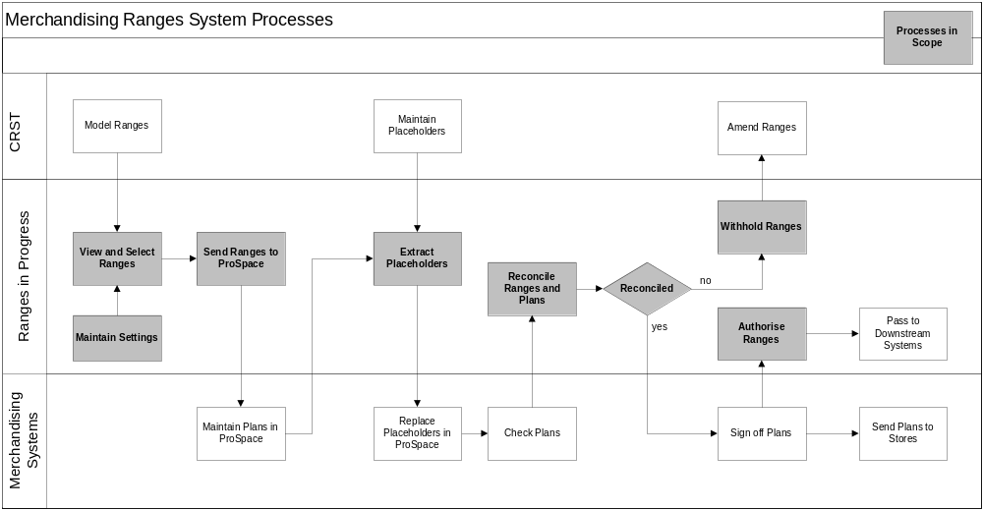

System Design

Ranges in Progress Screen Navigation
The system, Ranges in Progress, consists of a set of screens that will follow the following navigation principles.
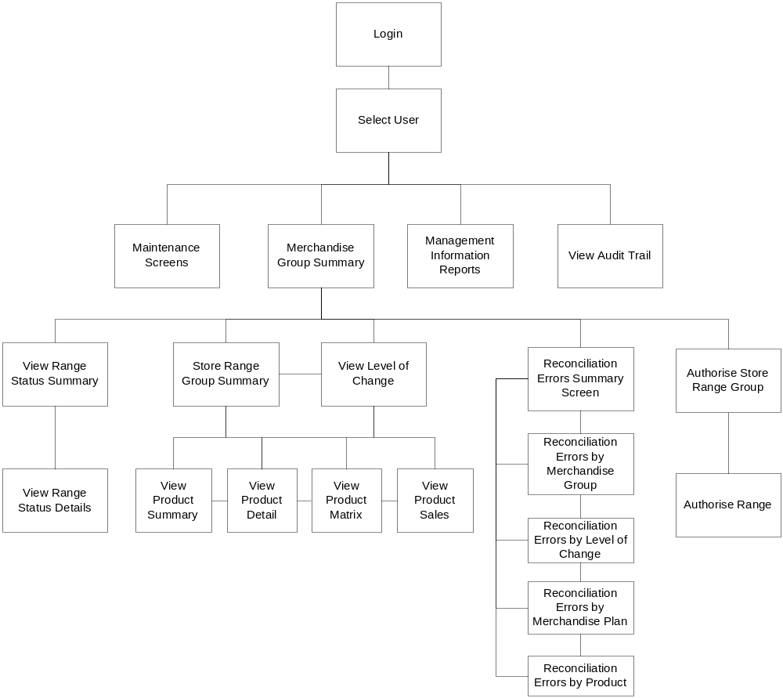
The screen layouts in this document are not intended to represent their final design. They illustrate the data that will be displayed and the functionality that will be present in each screen, without attempting to show every detail of how this functionality will be achieved (i.e. features such as radio buttons, check-boxes, scroll bars etc. are omitted). For the same reason, standard buttons such as ‘OK’ and ‘Cancel’ are not shown, although they will be present, where necessary, on the screens that are implemented. Final screen designs will be documented in the Technical System Design (TSD) and they will be signed off by the Business Project Team.

System Processes
The following sections describe the system functions and the screen requirements that support the business requirements documented in the Business Requirements Document, BRD5 Merchandising CRST Ranges.
There is a general requirement that all screens will be printable and that the date and time of the print request will be printed. Additionally information on the screens should be able to be copied and pasted into Word or Excel or email forms without the need for re-formatting.

Login in
The user will enter the system via a login screen using a designated user id and password. Access to the system will be restricted to CRST and Merchandising users, controlled by an administrative function within the system. See section 4.3 for a more detailed definition of system access and security.

Select User
On logging in the user will have access to view and/or process range data for the merchandising groups for which they are responsible. This screen will permit the user to select another user profile, allowing them to view and/or process other merchandising groups on behalf of other users.
See section 4.5 for more details on data access privileges.

View and Select Ranges

View ranging data at a number of different levels. | M
View supported space breaks and equipment types and ensure that ranges have been created for the necessary space breaks. | M

A set of screens in Ranges in Progress will allow Merchandisers to view specific range data created in CRST. Data will be available to view at merchandising group, store cluster and individual space break levels.

Merchandising Group Summary Screen
The purpose of this screen is to display a summary of data for the merchandising groups that have been scheduled on the Space, Range and Merchandising schedule, have been ranged in CRST and that require planning in ProSpace.

Merchandising Group Summary
Sort Order:
Range Change ID | Tesco Week Number | Range Effective Date |  | Authorisation Deadline | Merch Group Code | Merch Group Desc |  | Type of Range Change | % Change to Last Auth Range (Merch Group) |  | Last Sent to RIP | Merch Group Range Status | Status Last Updated |  | Sales History Period used |  |  |  | Sales History Agreed | Forecast Override
 |  |  |  |  |  |  |  |  |  |  |  |  |  |  | Fixed or Rolling Period | Fixed Start Date | Fixed End Date |  | Sales History Agreed | Forecast Override
001 | 09 | 01/05/2005 |  | Dd/mm/yyyy | B1B | Bread |  | Update | 10% |  | Dd/mm/yyyy  Hh:mm | Auth | Dd/mm/yyyy  Hh:mm |  | Fixed | yyyyww | Yyyyww |  | ✓ | Y/N
002 | 11 | 15/05/2005 |  | Dd/mm/yyyy | S1G | Cereal |  | New Merch Plan | 28% |  | Dd/mm/yyyy  Hh:mm | In Prog | Dd/mm/yyyy  Hh:mm |  | Rolling nn weeks |  |  |  | ✓ | Y/N
003 | 16 | 19/06/2005 |  | Dd/mm/yyyy | G3A | Canned Fruit |  | New Merch Plan | 25% |  | Dd/mm/yyyy  Hh:mm | In Prog | Dd/mm/yyyy  Hh:mm |  | Rolling nn weeks |  |  |  |  | Y/N
004 | 16 | 19/06/2005 |  | Dd/mm/yyyy | D2A | Milk |  | Refresh | 20% |  | Dd/mm/yyyy  Hh:mm | Not Received from Ranging | Dd/mm/yyyy  Hh:mm |  | Fixed | yyyyww | Yyyyww |  |  | Y/N
View Range Status |  |  | View Store Range Group Information |  |  |  | Reconcile Range |  |  | Authorise Range |  |  |  | View/Print Authorisation Report |  |  |  | Print Screen

On entering this screen, Merchandisers will initially see a list of merchandising groups appropriate to the selected user and for which range changes have been scheduled and ranged in CRST and are required to be merchandised. Only range changes scheduled up to 52 weeks from the current system date will be displayed.
There will be some ranges created in CRST that do not require merchandising. These ranges will not be visible in Ranges in Progress as they do not require Merchandising authorisation.
For each merchandising group ranged in CRST the following fields will be displayed in the following order:
- Range Change Id.
- Tesco week number
- Range effective date (defined as the earliest date a store cluster is to become effective within a given range change, defined in the Space, Range and Merchandising schedule)
- Authorisation Deadline (the final date by which the range must be authorised in Ranges In Progress, week –4 from the range effective date, for all range change types and merchandising groups)
- Merchandising group code
- Merchandising group description
- Type of Range Change (Range Change Type: New, Update, Refresh, Out of Cycle defined in Space, Range and Merchandising schedule)
- Percentage change to the last authorised range at merchandising group level. This is defined as:
Number of TPNBs in Last Authorised range for the whole merchandising group(e.g. 100)
Number of new TPNBs in the merchandising group(e.g. 15)
Number of TPNBs removed from the merchandising group (e.g. 5)
Number of changes made (e.g. 15 new lines + 5 de-lists = 20)
Percentage change (e.g. 20 / 100 = 20%)

All calculations should exclude overlay lines. The number of new and removed TPNBs will include any Out Of Cycle changes made since the last scheduled range change.
Percentage Change fields should be colour coded according to the parameters set in the Space, Range and Merchandising Schedule, examples of which are described in section Error: Reference source not found.
If there are zero products in the last authorised range the field should be populated with the word “New” and colour coded green.

- Date and Time that the range data was submitted from CRST to Ranges in Progress
- Merchandising Group Range Status, defined as:
- Not Received from Ranging System
- In Progress
- Authorised
- Cancelled
Merchandising group statuses will be derived from the combination of statuses recorded at individual space break level. These are defined in Range Status. Merchandising Group Range status fields will be colour coded, depending on the status of the individual space breaks, and also defined in Appendix 1.
- Last Status Update Date/Time (the date and time when the status of any space break in any of the store clusters for the merchandising group was last changed as a result of a system or user action)
- Sales History Period Used (showing the period used as “Fixed” or “Rolling”, the number of weeks rolling or the fixed start and end dates)
- Sales History Agreed flag (a check box to allow Merchandising to indicate that they have agreed the sales history period used for forecasting)
- Forecast Override (a Y/N indicator to show if a Commercial Forecast has been submitted for any existing products [products in the last authorised range] in any of the space breaks, in any of the store clusters for the merchandising group. New lines will be discounted.)

Data will be sorted initially by Range Effective Date (closest date first)
However, the user may choose to sort by:
- Merchandising Group Code (alphabetical, ascending/descending)
- Range Change Type (in order of New Merchandise Plan, Refresh, Update, Out of Cycle)
- Sales History Period
The sort order selected will be displayed on the screen.

Data in Ranges In Progress will displayed for a period of time beyond the range effective date as defined in the table below.
Merchandising Group Status | Remove from Ranges in Progress Merchandising Group Summary Screen
Not Received from Ranging System | Do not delete
In Progress | Do not delete
Authorised | Delete 7 days after range effective date
Cancelled | Delete 7 days after range effective date

From this Merchandising Group Summary screen the user will select a single merchandising group and opt to do one of the following:
- View Store Range Group Status (see section 4.2.3.3)
- View/Print the Final Authorisation Report (see section 4.4.1
- View the Store Range Group Information, displayed on a set of 2 tabs
- View Store Range Group Summary(see section 4.2.3.4)
- View Level of Change (see section 4.2.3.5)
- Reconcile ranges and plans at store cluster level (see section 4.2.5)
- Authorise ranges (see section 4.2.7) (restricted to Merchandising only)

Merchandising will automatically be informed when new ranges have been sent for planning. | S

Automated alerting functionality is out of scope for the initial delivery of the CRST project.
This process will therefore be supported manually. Commercial may inform Merchandising, either verbally or via email, that ranges have been exported from CRST, and/or Merchandising will check Ranges in Progress as part of their work routine.

There should be no restriction on the number of range changes Merchandising can view for the same merchandising group/store cluster that are being planned concurrently with different range effective dates, e.g. a new merchandise plan and an update plan which are being worked on at the same time. | M

In cases where different types of range changes, e.g. New Merchandise Plan and an Update, are being planned concurrently for the same merchandising group the system will support more than one set ranging data for the same merchandising group with different range effective dates.
The range change will be uniquely defined by the range change id.

View ranging data for two or more merchandising groups at the same time, e.g. main and supplementary merchandising groups. | M

The system will allow users to view data at each of the levels for more than one merchandising group or store cluster through the use of multiple windows.

Range Status Summary Screen
The purpose of this screen is to enable the user to view a summary of the status of the range for each space break/store clusters for the selected merchandising group.

Range Status Summary

Merchandising Group Code D2E
Merchandising Group Description Milk
Range Effective Date 19/05/2005
Tesco Week No. 16
Range Change Type Refresh
Range Change ID

Store Range Group | Effective Date | Reg.  Code | Range Status
Store Range Group | Effective Date | Reg.  Code | Cancelled | Not received from Ranging System |  | Received from Ranging System | Sent to Merch System |  | Authorised |  | Not Authorised
England, Wales, Superstores & Extras | 19/05/05 | A |  | 3 |  |  | 2 |  | 1
Scotland Superstores & Extras | 26/05/05 | S |  |  |  | 10
UK, Metro, Upmarket | 26/05/05 | E |  |  |  |  | 15
 |  |  |  |  | View Range Status Details |  |  | Back to Merchandising Group Summary |  | Print

On this screen the following fields will be displayed:
- Merchandising group code and description
- Range effective date and Tesco Week No
- Range Change Type and Id.

For the merchandising group selected, there will be data for one or more store clusters. For each store cluster the following data will be displayed in rows:
- Store range group description
- Store Range Group Effective date (which maybe different from the Range Effective Date)
- Region Code
Store Clusters will be ordered by store range group effective date (closest first) and then by number of stores in the store cluster (largest first).
Range status will be displayed in columns across the screen and, for each status, the count of the space breaks possessing that status will be shown.

Range statuses for space breaks are defined as:

Status displayed in Ranges in Progress | System Status | Definition/Triggers
Not Received from Ranging System |  | Range changes that have been scheduled on the Space, Range and Merchandising schedule for supported space breaks but have not yet been submitted.
Received from Ranging System | Received | Range data for a space break has been received from CRST and has not yet been sent to ProSpace. If a range has been re-submitted from CRST the status will be reset to Received regardless of the previous status.
Sent to Merch System | Sent | Range data for a space break has been selected and sent to ProSpace.
Authorised | Authorised | Ranging data for a space break has been authorised by the users.
Cancelled | Cancelled | A range has been removed from the Space, Range and Merchandising schedule.

The user will then navigate to the View Range Status Details screen to view the status of store clusters in more detail.

Range Status Details Screen
The purpose of this screen is to display the individual statuses of each of the space breaks in each of the store clusters for the selected merchandising group.

Range Status Details

Merchandising Group Code D2E
Merchandising Group Description Milk
Range Effective Date 19/05/2005
Tesco Week No. 16
Range Change Type Refresh
Range Change ID

Store Range Group | Range Effective Date | Region Code | Range Status
England, Wales, Superstores & Extras | 19/05/05 | A | Cancelled | Not Received from Ranging System | Received from Ranging System | Sent to Merch System |  | Authorised | Not Authorised | Reason Code |  | Comments
Z |  |  |  |  |  |  |  | ●
X |  |  |  |  |  |  |  |  | ●
S |  |  |  |  |  |  |  |  | ●
P |  |  |  | ●
K |  |  |  | ●
H |  |  |  | ●
Scotland, Superstores and Extras | 26/05/05 | S
Z |  |  |  |  | ●
W |  |  |  |  | ●
G |  |  |  |  | ●
etc
 |  |  |  |  |  |  | Back to Range Status Summary |  |  |  | Print

For the selected merchandising group the screen will display:
- Merchandising group code and description
- Range effective date and Tesco Week No
- Range Change Type and Id.
The following will be displayed in rows:
- Store range group description
- Store Range Group Effective date (which maybe different from the Range Effective Date)
- Region Code
- Supported space breaks for each of the store clusters
Store Clusters will be ordered by store range group effective date (closest first) and then by number of stores in the store cluster (largest first). Space breaks will be ordered alphabetically, descending.
Range status will be displayed in columns across the screen and there will an indicator to show the range status for each space break in each of the store range groups.

Store Range Group Summary Screen (Tab 1)
This screen is accessed from the Merchandising Group Summary screen by selecting a merchandising group and selecting the “View Store Range Group” option .The purpose of this screen is to:
- Provide a summary of range information at store cluster level
- Indicate where ranges are expected and have been submitted from CRST, enabling the Merchandiser to identify if any ranges are missing
- Select and send ranges to ProSpace for planning

Store Range Group Summary

Merchandising Group Code D2E
Merchandising Group Description Milk
Range Effective Date 19/05/2005
Tesco Week No. 16
Range Change Type Refresh
Range Change ID

Store Range Group | Effective Date | Region Code | No of Stores Ranged per Store Range Group | %Change to Last Auth Range (Store Range Group) |  | Range Class |  | Z |  |  |  | → |  |  | A
 |  |  |  |  |  | No. of Mods of Std Equipment |  | 20 |  | 18 |  |  |  | 12
England, Wales, Superstores & Extras | 19/05/05 | A | 87 | 24% |  | A |  | x |  | x |  |  |  | x
Scotland Superstores & Extras | 26/05/05 | S | 23 | 15% |  | S |  | ✓ |  |  |  |  |  | ✓
UK, Metro, Upmarket | 26/05/05 | E | 117 | 13% |  | E |  |  |  |  | ✓ |  |  |  | ✓
 |  |  | View Product Information |  | Send Ranges to Merch Systems |  | Key  = Submitted from Commercial  = Selected to send to Merch Systems  = Already sent to Merch Systems

On this screen the following fields will be displayed:
- Merchandising group code and description
- Range effective date and Tesco Week No
- Range Change Type and Id.
- All valid space breaks
For the merchandising group selected, there will be data for one or more store clusters. For each store cluster the following data will be displayed in rows:
- Store range group description
- Store Range Group Effective date (which maybe different from the Range Effective Date)
- The number of stores ranged (defined as the number of stores that will be in the store cluster on the range effective date)
- Percentage Change to Last Authorised Range by store cluster, defined as:
Number of TPNBs in Last Authorised range for the whole cluster (e.g. 100)
Number of new TPNBs in the cluster (e.g. 15)
Number of TPNBs removed from the cluster (e.g. 5)
Number of changes made (e.g. 15 new lines + 5 de-lists = 20)
Percentage change (e.g. 20 / 100 = 20%)
These fields should be colour coded according to parameters set in the Range, Space and Merchandising Schedule, described in section Error: Reference source not found).
If there are zero products in the last authorised range the field should be populated with the word “New” and colour coded green.
- Region Code (for the store cluster, defined in the pre-ranging activity)
All valid space breaks will be displayed in columns across the screen. The following metrics will be indicated:
- The space breaks for which a range has been received from CRST (ranges with a status of received)
- A range has been selected for export to ProSpace (set by the user)
- A range has been exported to ProSpace (ranges with a status of sent)
- The number of mods for the primary equipment type for the primary store cluster (defined in the Future Dated Space Matrix). (Displayed on screen as No. of Mods for Main Cluster)

Store Clusters will be ordered by store range group effective date (closest first) and then by number of stores in the store cluster (largest first).

Default selection to supported space breaks and equipment types. | M

All ranges received from CRST will be pre-selected for sending to ProSpace by default. The merchandiser can choose to amend the defaulted selection, de-selecting individual space breaks or whole store clusters as required.
An indicator on the Store Range Group Summary Screen will show that the range has been selected for export to ProSpace. A different indicator will show that the range has been exported. If a range is re-submitted from CRST the indicator will change back to the default selection to show that there is an amended range waiting to be re-sent to ProSpace.
The numbers of mods of the primary equipment type representing each of the supported space breaks will be displayed on this screen. All supported equipment types, with the corresponding number of mods, will be displayed on the Product Summary screen so that the merchandiser is aware of which plans to build for a given range. The source of this data will be the Future Dated Space Matrix.
Only one instance of a range will be sent to ProSpace, regardless of how many equipment types are supported for a given space break.

Select ranging data for import to ProSpace by merchandising group and/or store cluster and/or space break. | M

Data from any number of store clusters and space breaks for the merchandising group may be selected at a time. The process will be flexible enough to allow the selection of:
- all store clusters, all supported space breaks
- all supported space breaks within a single store cluster
- selected space breaks across multiple store clusters
Range data may be selected and sent to ProSpace at any time while the range is in progress, regardless of whether it has already been imported and regardless of system status.
From this screen the user can choose to:
- Select the View Level of Change tab (see section 4.2.3.5)
- Select a store cluster and view the product information. This will navigate to a set of four tabs:
- View Product Summary (see section 4.2.3.6)
- View the Product Detail (see section 4.2.3.7)
- View Product Matrix (see section 4.2.3.8)
- View the Product Sales (see section 4.2.3.9)
- Send the selected ranges to ProSpace (see section 4.2.4)

Level of Change (Tab 2)
This screen is accessed from the Merchandising Group Summary screen by selecting a merchandising group and selecting the “View Store Range Group” option.
The purpose of this screen is to show, as a percentage, the extent to which a range has changed at individual space break level.
Level of Change

Merchandising Group Code D2E
Merchandising Group Description Milk
Range Effective Date 19/05/2005
Tesco Week No. 16
Range Change Type Refresh
Range Change ID

Store Range Group | Effective Date | % Change to Last Auth Range (Store Range Group) |  | % Change to Last Authorised Range (Range Class)
Store Range Group | Effective Date |  |  | Z | → |  |  |  |  |  |  |  |  |  |  | A
England, Wales, Superstores & Extras | 19/05/05 | 24% |  | 20% |  | 16% |  |  | 10% |  | 5% |  |  |  | 3% | 1%
Scotland Superstores & Extras | 26/05/05 | 15% |  | 24% |  | 17% |  |  | 5% |  | 8% |  |  |  | 7% | 18%
UK, Metro, Upmarket | 26/05/05 | 13% |  |  | 5% |  |  |  | 12% |  |  |  |  | 15%
 |  |  | Back to Store Range Group Summary |  |  |  |  | View Product Information |  |  |  |  | Print

On this screen the following fields will be displayed:
- Merchandising group code and description
- Range effective date and Tesco Week No
- Range Change Type and Id.
For the merchandising group selected, there will be data for one or more store clusters. For each store cluster the following data will be displayed in rows:
- Store range group description
- Store Range Group Effective date (which maybe different from the Range Effective Date)
- Region Code (for the store cluster, defined in the pre-ranging activity)
- Percentage Change to Last Authorised Range at Store Range Group level (as previously defined). These fields should be colour coded according to parameters set in the Merchandise Schedule, described in section Error: Reference source not found).
All valid space breaks will be displayed in columns across the screen. The following measures will be indicated:
- percentage change to the last authorised range at space break level for each supported space break defined as:
Number of TPNBs in Last Authorised range (e.g. 100 lines in space break A)
Number of new TPNBs in the space break (e.g. 15 in space break A)
Number of TPNBs removed from the range (e.g. 5 from space break A)
Number of changes made (e.g. 15 new lines + 5 de-lists = 20)
Percentage change (e.g. 20 / 100 = 20%)
These fields should be colour coded according to parameters set in the Range, Space and Merchandising Schedule, described in section Error: Reference source not found).
If there are zero products in the last authorised range the field should be populated with the word “New” and colour coded green.

From this screen the user can choose to:
- Select the Store Range Group Summary tab
- Select a store cluster and view the product information. This will navigate to a set of four tabs:
- View Product Summary (see section 4.2.3.6)
- View the Product Detail (see section 4.2.3.7)
- View Product Matrix (see section 4.2.3.8)
- View the Product Sales (see section 4.2.3.9)

Product Summary Screen (Tab 1)
This screen is accessed from the Store Range Group Summary screen or the View Level of Change screen by selecting a single store cluster and choosing the “View Product Information” option.
The purpose of this screen is to display a summary of information for the selected store cluster to enable the Merchandiser to assess the level of work required to merchandise the store cluster.

Product Summary

Merchandising Group Code D2E
Merchandising Group Description Milk
Range Effective Date 19/05/2005
Tesco Week No. 16
Range Change Type Refresh
Range Change ID
England, Wales, Superstores & Extras  SRG Effective Date 19/05/2005 | Region  Code  A | Z | S | P
STD (no. of mods) |  | 20 | 18 | 12
LLD (no. of mods) |  |  |  | 14
HLD (no. of mods) |  | 16
Number of Stores Ranged per Range Class |  | 6 | 12 | 18
% Change to Last Authorised Range |  | 26% | 23% | 21%
Total No. of Core Products in Range |  | 205 | 180 | 123
No. of New Core Products |  | 22 | 16 | 10
No. of Deleted Core Products |  | 18 | 16
Total No. of Overlays |  | 5 | 5
No. of New Overlays |  | 2 | 2
No. of Deleted Overlays |  | 2 | 2
Changes to Last Sent Range |  | ✓ |  | ✓
 |  |  |  |  |  | Back to Store Range Group Summary |  |  |  |  | Print

On this screen the following fields will be displayed:
- Merchandising group code and description
- Range effective date and Tesco Week No
- Range Change Type and Id.
- Store range group description
- Store Range Group Effective date (which maybe different from the Range Effective Date)
- Region Code
For the selected store cluster, for each supported space break there will be a summary of:
- the supported equipment types and the corresponding number of mods for each space break (defined by the Future Dated Space Matrix)
- the number of stores ranged (defined as the number of stores in each space break for the store cluster/merchandising group. This will be calculated in CRST and referred to as Numbers of Stores))
- the percentage change to the last authorised range at space break level, as previously defined (these fields should be colour coded according the parameters set in the Merchandise Schedule, described in section Error: Reference source not found)
- the number of core products in the range for each space break (the total number of products in the range, excluding overlay lines)
- the number of new core products in the range for each space break (defined as the number of products present in the new range sent from CRST which are not currently present in the last authorised range)
- the number of deleted core products in the range for each space break (defined as the number of products present in the last authorised range but not present in the new range sent from CRST)
- the number of overlay lines in the range for each space break (defined as those products in the new range which have an overlay attribute)
- the number of new overlay lines in the range for each space break (defined as the number of overlay products present in the new range sent from CRST which are not currently present in the last authorised range)
- the number of deleted overlay lines in the range for each space break (defined as the number of products present in the last authorised range but not present in the new range sent from CRST)
- an indication if the range has been amended since it was last sent to ProSpace (derived by comparing the products in each space break for the most recently sent range and the work in progress product list in ProSpace. If the product list is different, or if there is no product list in ProSpace to compare with then a change will be indicated).

Product Detail Screen (Tab 2)
The purpose of this screen is to display a list of products for the selected store cluster and summarise where they have been ranged, indicating whether they are new, deleted, discontinued, extended, reduced or overlay products.

Product Detail

Merchandising Group Code D2E
Merchandising Group Description Milk
Range Effective Date 19/05/2005
Tesco Week No. 16
Range Change Type Refresh
Range Change ID
England, Wales, Superstores & Extras  Effective Date 19/05/2005 |  |  | Region  Code  A
Product  TPNB / Description | Product Type | Overlay Substitution  TPNB / Description |  | As Is  Range Class |  |  | To Be Range Class
Product  TPNB / Description | Product Type |  |  | Lowest | Highest |  | Lowest | Highest
Subgroup 1
TPNB 5 B/berry Muffin | New |  |  |  |  |  | L | Z
TPNB 7 Orange Muffin | New |  |  |  |  |  | S | Z
TPNB 8 Blue Muffin | Deleted |  |  | L | Z
TPNB 9 Green Muffin | Deleted |  |  | S | Z
TPNB 4 Choc Muffin | Extension |  |  | P | Z |  | L | Z
TPNB 6 Soda Bread | Reduction |  |  | L | Z |  | P | Z
TPNB 1 White Rolls | No Change |  |  | F | Z |  | F | Z
TPNB 2 Brown Rolls | No Change |  |  | L | Z |  | L | Z
TPNB 3 Ciabata | No Change
TPNB 3 Ciabata | Overlay | TPNB 1 White Rolls |  | F | Z |  | F | Z
TPNB 3 Ciabata | Overlay | TPNB 2 BrownRolls
Subgroup 2
 |  |  |  |  |  | Back to Store Range Group Summary |  |  | Print Screen

A list of products will be displayed for the selected store cluster that represents:
- Ranged products that are “active” in CW with a status of “A”.
- Ranged “deactivated” products that are intended to be active at the date the range becomes effective (such as seasonal lines), with a CW status of “O”, “R” or “S”
- Ranged Placeholders
- Ranged Overlays (identified by an overlay attribute)
- Deleted products
The product list will be a complete list of products in the store cluster, including placeholders, overlays and deleted products.
For each product listed the following data will be available to view:
- TPNB or placeholder number
- Product Description
- Product Type
- New (defined as a product that was not ranged in any space break for the selected store cluster in the last authorised range)
- Extended (defined as a product that is new to a space break but is present in a higher space break for the selected store cluster)
- Reduced (defined as a product that is has been removed from a space break but is still present in a higher space break for the selected store cluster)
- Change ( a product that has been moved between space breaks where the movement cannot be described simply as an extension or a reduction
- Deleted (a product that was present in the store cluster in the last authorised range but is not present in the store cluster in the last sent range)
- Discontinued (a product that was present in the store cluster in the last authorised range but is not present any the store cluster in the last sent range)
- No Change (defined as a product that is present anywhere in the same space break in the last authorised range and the last sent range)
- Overlay (a product ranged in CRST as an overlay and presented to Ranges in Progress in the overlay file. An overlay may also appear in the range as a core product).
- Overlay substitution (the core product to be replaced by the overlay product, presented to Ranges in Progress in the overlay file. An overlay may be associated with more than one core product within a range)
- As Is Range Class (the lowest and the highest space breaks that the product occurs in the last authorised range) *
- To Be Range Class (the lowest and the highest space break that the product occurs in the last sent range) *

Products will be ordered numerically by TPNB (ascending or descending), grouped by:
- subgroup, alphabetical ascending
- product type in the order of new, extended, reduced, deleted, no change and overlay
The list can be filtered by product type to show:
- All products
- New, deleted, extended, reduced products only
- New and deleted products only
- Extended and reduced products only
- Overlay products only
- New products only
- Deleted products only
- Extended products only
- Reduced products only
- No change products only

* These measures assume that the product is ranged in all space breaks between the lowest and highest. The value of these measures will need to be reviewed if the business moves to allow fragmenting of ranges.

Product Matrix Screen (Tab 3)
The purpose of this screen is to display a list of products for the selected store cluster and show where they have been ranged, indicating whether they are new, deleted, extended, reduced or overlay products.

Product Matrix

Merchandising Group Code D2E
Merchandising Group Description Milk
Range Effective Date 19/05/2005
Tesco Week No. 16
Range Change Type Refresh
Range Change ID
England, Wales, Superstores & Extras  Effective Date 19/05/2005 |  |  | Region  Code  A
No. Of New Core Products |  |  |  | 22 | 16 |  | 10
No. Of Deleted Core Products |  |  |  | 18 | 16
Product  TPNB / Description | Product Type | Overlay Substitution  TPNB / Description |  | Z | S |  | P | M |  | K
Subgroup 1
TPNB 5 B/berry Muffin | New |  |  | ✓ | ✓ |  | ✓ | ✓ |  | ✓
TPNB 7 Orange Muffin | New |  |  | ✓ | ✓
TPNB 8 Blue Muffin | Deleted |  |  | x | x |  | x | x |  | x
TPNB 9 Green Muffin | Deleted |  |  | x | x
TPNB 4 Choc Muffin | Extension |  |  | ● | ● |  | ● | ✓ |  | ✓
TPNB 6 Soda Bread | Reduction |  |  | ● | ● |  | ● | x |  | x
TPNB 1 White Rolls | No Change |  |  | ● | ● |  | ● | ● |  | ●
TPNB 2 Brown Rolls | No Change |  |  | ● | ● |  | ● | ● |  | ●
TPNB 3 Ciabata | No Change |  |  | ● | ●
TPNB 3 Ciabata | Overlay | TPNB 1 White Rolls |  |  |  |  | ●
TPNB 3 Ciabata | Overlay | TPNB 2 BrownRolls |  |  |  |  |  | ●
Subgroup 2
Key:  Green ✓ = Product new to space break  Red x = Product removed from space break  Black  = No change |  |  |  |  |  | Back to Store Range Group Summary |  |  | Print Screen

A list of products will be displayed for the selected store cluster that represents:
- Ranged products that are “active” in CW with a status of “A”.
- Ranged “deactivated” products that are intended to be active at the date the range becomes effective (such as seasonal lines), with a CW status of “O”, “R” or “S”
- Ranged Placeholders
- Ranged Overlays (identified by an overlay attribute)
- Deleted products
The product list will be a complete list of products in the store cluster, including placeholders, overlays and deleted products.
For each product listed the following data will be available to view:
- TPNB or placeholder number
- Product Description
- Product Type (for store cluster)
- New (defined as a product that was not ranged in any space break for the selected store cluster in the last authorised range)
- Extended (defined as a product that is new to a space break but is present in a higher space break for the selected store cluster)
- Reduced (defined as a product that is has been removed from a space break but is still present in a higher space break for the selected store cluster)
- Deleted (a product that was present in the store cluster in the last authorised range but is not present in the store cluster in the last sent range)
- Discontinued (a product that was present in the store cluster in the last authorised range but is not present any the store cluster in the last sent range)
- No Change (defined as a product that is present anywhere in the same space break in the last authorised range and the last sent range)
- Overlay (a product ranged in CRST as a overlay and presented to Ranges in Progress in the overlay file. An overlay may also appear in the range as a core product).
- Overlay substitution (the core product to be replaced by the overlay product, presented to Ranges in Progress in the overlay file. An overlay may be associated with more than one core product within a range)
- An indicator to show the space breaks that each product has been ranged to or deleted from

The screen will also display the total number of new and deleted core products in each space break, as defined in the Product Summary Screen.
Products will be ordered numerically by TPNB (ascending or descending), grouped by:
- subgroup, alphabetical ascending
- product type in the order of new, extended, reduced, deleted, no change and overlay
The list can be filtered by product type to show:
- All products
- New, deleted, extended, reduced products only
- New and deleted products only
- Extended and reduced products only
- Overlay products only
- New products only
- Deleted products only
- Extended products only
- Reduced products only
- No change products only

Product Sales Screen (Tab 4)

Forecasted Sales should be displayed, at product/space break level, where they exist. If not, To Be sales should be displayed. To Be sales and Forecasted sales should be distinguishable. | M

The purpose of this screen is to view the system generated To Be Sales and Commercial Forecast Sales by space break for each product in the selected store cluster.

Product Sales

Merchandising Group Code D2E
Merchandising Group Description Milk
Range Effective Date 19/05/2005
Tesco Week No. 16
Range Change Type Refresh
Range Change Id.
England, Wales, Superstores & Extras  Effective Date 19/05/2005 |  |  |  | Region  Code  A |  | Forecast (sgls or wt)  (Average Weekly Sales/Store/Space break)
Product TPNB / Description |  | Product Type |  | Z |  |  | S | P |  | M |  | K
Subgroup 1
TPNB 5 B/berry Muffin | New |  | System |  | nnn |  | nnn | nnn
TPNB 5 B/berry Muffin |  |  | Commercial |  | nnn
TPNB 7 Orange Muffin | New |  | System |  | nnn
TPNB 7 Orange Muffin |  |  | Commercial
TPNB 8 Blue Muffin | Deleted |  | System
TPNB 8 Blue Muffin |  |  | Commercial
TPNB 9 Green Muffin | Deleted |  | System
TPNB 9 Green Muffin |  |  | Commercial
TPNB 4 Choc Muffin | Extension |  | System |  | nnn |  | nnn | nnn
TPNB 4 Choc Muffin |  |  | Commercial |  | nnn |  |  | nnn
TPNB 6 Soda Bread | Reduction |  | System |  | nnn |  | nnn | nnn
TPNB 6 Soda Bread |  |  | Commercial
TPNB 1 White Rolls | No Change |  | System |  | nnn |  | nnn | nnn |  | nnn |  | Nnn
TPNB 1 White Rolls |  |  | Commercial |  | nnn |  |  | nnn |  |  |  | Nnn
TPNB 2 Brown Rolls | No Change |  | System |  | nnn |  | nnn | nnn
TPNB 2 Brown Rolls |  |  | Commercial
TPNB 3 Ciabata | Overlay |  | System |  | nnn |  | nnn | nnn |  | nnn |  | Nnn
TPNB 3 Ciabata |  |  | Commercial |  | nnn |  |  | nnn |  | nnn
Subgroup 2
 |  |  |  |  |  |  |  |  | Back to Store Range Group Summary |  | Print Screen

The product list will be a complete list of products in the store cluster including placeholders, overlays and deleted products. Deleted lines will be listed in the product list but sales fields will be left blank.

For each product listed the following data will be available to view:
- TPNB or placeholder number
- Product Description
- Product Type (as defined in the View Product Detail screen)
- The space breaks each product has been ranged to
- System To Be Sales, average units/store/week, generated by CRST, for each of the space breaks (non-weighted products only)
- Commercial Forecasted Sales, average units/store/week, user defined in CRST, for each of the space breaks (non-weighted products only)
- System To Be Sales, average weight/store/week, generated by CRST, for each of the space (weighted products only)
- Commercial Forecasted Sales, average weight/store/week, user defined in CRST, for each of the space (weighted products only)
Products will be ordered numerically by TPNB (ascending or descending), grouped by:
- sub group (alphabetical ascending)
- product type in the order of new, extended, reduced, deleted, no change and overlay
Products can be filtered to show only those where a Commercial Forecast exists or to show all, or to show only New Lines. The default view will be of products for which a Commercial forecast exists

Forecasts will be calculated in CRST and passed to RIP. Commercial can override these system-generated forecasts in CRST by entering a Forecast for any TPNB or placeholder.
The system-generated forecast, units or weight, will be passed to ProSpace, except where a commercial forecast exists; in this case it will be the commercial forecast that is sent to ProSpace for building merchandise plans.

Send Ranges to Merchandising Systems

Extract selected data hourly and make available to ProSpace. | M

Ranging data may be selected in Ranges In Progress at any level ready for extraction. Once selected it is sent to ProSpace by selecting the option to ‘Send Ranges to Merch Systems’ on the Store Range Group Summary screen. At this point, all of the selected ranges for each of the store clusters/space breaks for the selected merchandising group will be sent to ProSpace.
When a space break is selected to be sent to merchandising systems the range status will be switched from “Received ” to “Sent” and displayed on the View Range Status screen.
Indicators on the Store Range Group Summary screen will be set to show which of the ranges have been exported.
Extracted data will be sent to ProSpace and made available for planning within the hour.
The specification for the transfer of range data to ProSpace will be covered in a separate document (TBC).

Extracted ranges will not include overlay lines, except in the full product list for the FMPOG. | M

Ranges in Progress will filter ranges to remove overlay products before sending to ProSpace.
Each time a new range is submitted for authorisation from CRST (defined by the status “Submitted and Locked” in CRST), Ranges in Progress will compile a “dummy” range for the FMPOG. This will contain all products that have been ranged in CRST for the merchandising group, including overlay products and placeholders. These ranges will be identified by the 3 digit merchandising code followed by a region code of X and space break of X. Ranges for the FMPOG will be visible in Ranges in Progress and should be displayed as a range for the store range group Full Master Merch Plan for the “X” space break only.

Merchandising must not be prevented from selecting and exporting data from a range that has a status of ‘Rejected’. | M

Range data may be extracted and imported at any time while the range is in progress, regardless of whether it has already been imported and regardless of its status.
(The status of “Rejected” has be replaced by “Not Authorised”, see section 4.2.6)

Reconcile Ranges and Plans

Where ranges are planned in CRST and merchandised in ProSpace, reconciliation between ranges and merchandise plans is required. | M
Reconciliation between ranges and plans will be an automated process. | M
Merchandising and Commercial will be able to view the differences between a range and the corresponding merchandise plan (at line level). | M

The purpose of reconciliation is to identify:
- products which are in the range but not placed on the respective merchandise plan (including overlays in the FMPOG)
- products which are on the merchandise plan but not in the range
- placeholder id and description present in ranges and merchandise plans
- products contained in a plan that are currently unauthorised in CW
- products in a plan that do not meet level run down criteria in ProSpace
- products that do not fit on a merchandise plan
- unacceptable levels of change within space breaks
- ranges that are expected but have not yet been received from CRST
- where an inappropriate sales history period has been used
Reconciliation will be requested at store cluster level and will occur for every supported space break within the clusters selected.

Reconcile Store Range Group Screen
From the Merchandising Group Summary screen merchandising will select a merchandising group and elect to Reconcile Range. The following screen will then be displayed.
The purpose of this screen is to allow the user to select any number of store clusters to reconcile.
All store clusters will be pre-selected for reconciliation; the user will have to option to de-select store clusters and exclude them from the reconciliation process.

Reconcile Store Range Group

Merchandising Group Code D2E
Merchandising Group Description Milk
Range Effective Date 19/05/2005
Tesco Week No. 16
Range Change Type Refresh
Range Change Id.
Store Range Group | Effective Date | Region  Code | Date/Time Last Reconciled | Z | Y | W |  | V | U | T | S |  | R | → | A
England, Wales, Superstores & Extras | 19/05/2005 | A | 16/05/2005 17:34 | ✓ |  | ✓ |  |  |  |  | ✓
Scotland Superstores & Extras | 26/05/2005 | S |  | ✓ |  |  |  |  |  |  | ✓
UK, Metro, Upmarket | 26/05/2005 | E |  |  |  |  |  | ✓ |  |  |  |  | ✓ |  | ✓
Key:  = Range received from Ranging System  = Range Selected for Reconciliation |  |  |  |  |  |  | Reconcile |  |  |  |  | Print

On this screen the following fields will be displayed:
- Merchandising group code and description
- Range effective date and Tesco Week No
- Range Change Type and Id.
For the merchandising group selected, there will be data for one or more store clusters. For each store cluster the following data will be displayed in rows:
- Store range group description
- Store Range Group Effective date (which maybe different from the Range Effective Date)
- Region Code
- Date and Time Last Reconciled
All valid space breaks will be displayed in columns across the screen. The following measures will be indicated:
- The space breaks for which a range has been received from CRST
- A range has been selected for reconciliation

The user, having selected the store clusters to be reconciled, will then select the “Reconcile Store Range Group” option on the screen. At this point the reconciliation process will be initiated for all supported space breaks in the cluster.
During reconciliation the following system processing will run. If the condition fails the following errors will result.

Reconciliation Errors | System processing
Products in range, not on plan | For each range submitted by CRST for the selected merchandising group /store clusters, compare the products in the range with the products placed on corresponding Work in Progress (WIP) merchandise plans in ProSpace.  The range and plan will be matched on merchandising group code, space break, region code and range effective date.  If a product appears in a range but not on the corresponding plan an error will be raised. Report TPNB and product description and the plan id for which the error is true.  If more than one plan exists for a single range all plans will be compared to the single range and the errors attributed to the corresponding plan.  Reconciliation of the FMPOG is required using the derived range.
Products on plan, not in range | For each range submitted by CRST for the selected merchandising group /store clusters, compare the products in the range with the products placed on corresponding Work in Progress merchandise plans in ProSpace. If more than one plan exists for a single range all plans will be compared to the single range and the errors attributed to the corresponding plan.  If a product appears on a plan but is not in the range an error will be raised. Report TPNB and product description and the plan id for which the error is true.  Reconciliation of the FMPOG is required.
Placeholder in range | Check if any product in any of the ranges for the selected merchandising group is a placeholder.  If true an error is raised. One error per product per merchandising group. Report TPNB and product description.
Placeholder on plan | Check if any product in any of the merchandise plans in ProSpace for the selected merchandising group is a placeholder.  If true an error is raised. One error per product per merchandising group. Report TPNB and product description.  Reconciliation of the FMPOG is required.
Unauthorised products in range | Check if any product in any of the ranges for the selected merchandising group has a CW status of anything other than “A” authorised.  If true raise an error. One error per product per merchandising group. Report TPNB and product description.
Products in a plan that do not meet level run down criteria | Check if any of the product positions in any of the ProSpace WIP plans for the selected merchandising group /store clusters has a calculated highlight of “RED”.  If true raise an error. Report TPNB and product description and plan id for which the error is true.  Checking of the FMPOG is NOT required.
Products with warnings | Check if any of the product positions in any of the ProSpace WIP plans for the selected merchandising group /store clusters has a position warning. (All of the position warning values are valid and should be included)  If true raise an error. Report TPNB and product description and plan id for which the error is true.  Checking of the FMPOG is NOT required.
Unacceptable level of change | Check if any of the space breaks for the selected merchandising group/store clusters has a level of change that falls within the specified RED range appropriate to the range change type.  If true raise an error. One error per space break.
Ranges Not Received from Ranging System | Check that the supported ranges for the selected merchandising group/store have not been received from CRST.  If true raise an error. One error per space break.
Sales History Period Agreed? | The Sales History Agreed flag is set to N results in an error

Results of the reconciliation process will be available to view and print immediately. | M

The results of the reconciliation process will be displayed on the Reconciliation Errors screens with an option to print.
The date and time of the last reconciliation will be recorded and displayed on the Reconciliation errors screens.
The reconciliation process should take no more than 30 seconds, from the time the reconciliation request is made to the results being displayed.

Reconciliation Errors Summary Screen (Tab 1)
The first screen will provide a summary of reconciliation errors caused by product mismatches between ranges and plans.

View Reconciliation Errors Summary
Reconciliation Run: Date/Time
Merchandising Group Code D2E
Merchandising Group Description Milk
Range Effective Date 19/05/2005
Tesco Week No. 16
Range Change Type Refresh
Range Change Id.
Store Range Group | Effective Date | Region  Code | Number of Product Mismatches per Range
Store Range Group | Effective Date | Region  Code | Z | Y | W |  | V | U | T | S |  | R | → | A
England, Wales, Superstores & Extras | 19/05/2005 | A | 0 |  | 0 |  |  |  |  | 0
Scotland Superstores & Extras | 26/05/2005 | S | 5 |  |  |  |  |  |  | 15
UK, Metro, Upmarket | 26/05/2005 | E |  |  |  |  | 10 |  |  |  |  | 20 |  | 0
 |  |  |  |  |  | Back to Reconcile Store Range Group |  |  |  |  | Print

On this screen the following fields will be displayed:
- Merchandising group code and description
- Range effective date and Tesco Week No
- Range Change Type and Id.
- Reconciliation Run Date/Time (the date and time at which the reconciliation was last run)
For the merchandising group and store clusters selected the following data will be displayed in rows:
- Store range group description
- Store Range Group Effective date
- Region Code
All valid space breaks will be displayed in columns across the screen. The following measures will be indicated:
- The number of errors in each space break will be displayed.
Errors will only be counted if they are:
- Products in range, not on plan and have not been accepted by a Senior Merchandiser
- Products on plan, not in range and have not been accepted by a Senior Merchandiser
If the count of errors > 0 then the text will be displayed in red to indicate that action is required to clear the error.
If a product within a single range gives rise to errors on more than one plan each error will be counted separately.
For example, if a range is to be displayed on 3 different equipment types and a product is missing from each of those merchandise plans, 3 errors will be counted.

Reconciliation Errors by Merchandising Group (Tab 2)
The purpose of this screen is to display the reconciliation errors that apply to the merchandising group selected for reconciliation: placeholders, unauthorised products and unapproved sales history.

Reconciliation Errors by Merchandise Group
Reconciliation Run: Date/Time
Merchandising Group Code D2E
Merchandising Group Description Milk
Range Effective Date 19/05/2005
Tesco Week No. 16
Range Change Type Refresh
Range Change Id.

Dummy New Lines in Range
TPNB/ Description
TPNB /Description
TPNB/ Description
Dummy New Lines on Plan
TPNB/ Description
TPNB /Description
TPNB/ Description
Unauthorised Products in Range
TPNB/ Description
TPNB/ Description
TPNB/ Description
Sales History Agreed Y
 | Back to Reconcile Store Range Group | Print

On this screen the following fields will be displayed:
- Merchandising group code and description
- Range effective date and Tesco Week No
- Range Change Type and Id.
The errors, Dummy New Lines on Plan, Dummy New Lines in Range and Unauthorised Products in Range, will be displayed in rows, together with the list of TPNBs and product descriptions to which these errors apply.
The Sales History Agreed Flag will also be displayed

Reconciliation Errors by Level of Change (Tab 3)
The purpose of this screen is to display the reconciliation errors, level of change and outstanding ranges, at space break level.

Reconciliation Errors by Level of Change
Reconciliation Run: Date/Time
Merchandising Group Code D2E
Merchandising Group Description Milk
Range Effective Date 19/05/2005
Tesco Week No. 16
Range Change Type Refresh
Range Change ID

Store Range Group
Store Range Group |  | Z |  | → |  |  |  |  |  |  |  |  |  |  | A
England, Wales, Superstores & Extras | Level of Change | 50% |  |  | 41% |  | 40% |  |  | 55%
England, Wales, Superstores & Extras | Accept? | ✓ |  |  |  |  | ✓
 | Ranges Not Received from Ranging System
Scotland Superstores & Extras | Level of Change | 74% |  |  | 77% |  | 74%
Scotland Superstores & Extras | Accept?
 | Ranges Not Received from Ranging System
UK, Metro, Upmarket | Level of Change
UK, Metro, Upmarket | Accept?
 | Ranges Not Received from Ranging System |  |  |  | 3 | 5 |  |  |  | 7 |  |  |  | 7
Key:  ✓ = Select Error to Accept |  |  | Back to Reconcile Store Range Group |  |  |  |  |  | Accept Errors |  |  |  | Print

On this screen the following fields will be displayed:
- Merchandising group code and description
- Range effective date and Tesco Week No
- Range Change Type and Id.
- Reconciliation Run Date/Time (the date and time at which the reconciliation was last run)
All valid space breaks will be displayed in columns across the screen. The following measures will be indicated for the merchandising group and store clusters selected, displayed in rows:
- Store range group description
- Percentage Level of Change for each space break where a error has been raised
- The number of ranges Not Received from Ranging System (those ranges that are supported but have not been received from CRST)
- The user will be able to tick the Level of Change Errors in order to allow them to be authorised. If the error has been accepted then the error flag will be cleared for that space break.
Level of Change errors may only be accepted by Senior Merchandising Managers.

Reconciliation Errors by Merchandise Plan (Tab 4)
The purpose of this screen is to display reconciliation errors that apply to Merchandise plans.

Reconciliation Errors by Merchandise Plan
Reconciliation Run: Date/Time
Merchandising Group Code D2E
Merchandising Group Description Milk
Range Effective Date 19/05/2005
Tesco Week No. 16
Range Change Type Refresh
Range Change Id.

Scotland Superstores & Extras
Merch Plan Name |  |  | Accept? | Comments
Products on Plan, not in Range
TPNB | TPNB Description |  |  | Free form text entered by user
TPNB | TPNB Description
Products on Range not on Plan
TPNB | TPNB Description
TPNB | TPNB Description
TPNB | TPNB Description
Products with Warnings
TPNB | TPNB Description
TPNB | TPNB Description
TPNB | TPNB Description
Product failing Level Run Down
TPNB | TPNB Description
Plan Name
Etc…
 |  | Back to Reconcile Store Range Group |  |  | Accept Errors | Print

The screen will display the following for the selected merchandising group and store clusters:
- Reconciliation Run: Date/Time (the date and time that reconciliation was processed)
- Merchandising Group Code
- Merchandising Group Description
- Range Effective Date
- Tesco Week Number
- Range Change Type
- Range Change Id.
- Store Range Group Description
- Merch Plan Name
- TPNB and description of products that are in the range but not on the merchandise plan (error type Products in range, not on plan)
- TPNB and description of products not in the range but on the merchandise plan (error type Products on Plan, not in Range)
- Unauthorised products (products that do not have a status of Authorised in CW)
- Placeholders ID and description

Data will be ordered by Store Range Group Effective Date, (closest first), then by plan name in descending order.
The user will be able to select each of the errors to accept them and enter some free form text. If the error has been accepted then the error flag will be cleared for that range and no longer counted as an error. Acceptance of errors will be restricted to Senior Merchandising Managers only.
If the same error for a product appears in more than one plan and the user accepts one of those errors, the error flags should be cleared and the comments copied for all other instances of that product /error combination.
The accepted errors for a range only apply to the range last sent. If the range is resent from CRST, all accepted errors flags and reasons will be cleared.
If reconciliation has been triggered as part of the Authorise Range process then the all of the results of the reconciliation will need to be stored to provide the basis for management reports, see section 4.4.1.

Reconciliation Errors by Product (Tab 5)

Reconciliation Errors by Product
Reconciliation Run: Date/Time
Merchandising Group Code D2E
Merchandising Group Description Milk
Range Effective Date 19/05/2005
Tesco Week No. 16
Range Change Type Refresh
Range Change Id.

Scotland Superstores & Extras
Subgroup | TPNB | Description | Error Type | Plans/Ranges affected |  | Ranging System Range Class |  | Merchandise Plan Range Class
 |  |  |  |  |  | Lowest | Highest | Lowest | Highest
W61AA | TPNB | Bells 70cl | On plan, not in range | A |  | B | J | A | J
W61AA | TPNB | xxxxx | In range, not on plan | D |  | D | J | E | J
W61AA | TPNB | xxxxx | Placeholder | C, E, G, H, J |  | C | J | C | J
W61AA | TPNB | xxxxx | Unauthorised | H, I |  | H | I | H | I
W61AA | TPNB | xxxxx | Placeholder | J |  | J | J | J | J
 |  |  |  |  | Back to Reconcile Store Range Group |  |  |  | Print

On this screen the following fields will be displayed for the merchandising groups/store clusters selected:
- Merchandising group code and description
- Range effective date and Tesco Week No
- Range Change Type and Id.
- Reconciliation Run Date/Time (the date and time at which the reconciliation was last run)
- Store range group description
- Subgroup
- TPNB and Description for which errors have occurred
- Error type
- Plan/Range Affected (the plans or the ranges where the errors for that product exist)
- CRST Range Class* (defined as the lowest and highest space break that the product appears in the ranges for that cluster)
- Merchandise Plan Range Class (defined as the lowest and highest plan that the product appears in the store cluster )

The rows may be filtered by Error.
* These measures assume that the product is ranged in all space breaks between the lowest and highest. The value of these measures will need to be reviewed if the business moves to allow fragmenting of ranges.

Where plans and ranges cannot be reconciled the Merchandising and Commercial need to have visibility of ranges that need to be amended, at product level detail. | M

Both Commercial and Merchandising teams will have appropriate access to the Reconciliation Errors screen and the ability to print the screen. Additionally reports will be available to show reconciliation results at the point of range authorisation. N.B. this will not constitute a report on the accuracy of plans and ranges at the point at which they go live; it merely represents a view of the ranges and plans in progress at the point at which the reconciliation process was requested.

Reject Range

Rejection of a range will be at store cluster level | M
A reason for rejection (Reason Code and Comments) will be visible to Commercial | M
Merchandising can reject a range up to 4 weeks prior to range effective date (this includes a previously authorised range to allow for unforeseen circumstances, e.g. major factory shutdown impacting the range) | M
The Senior Merchandising Managers can reject a previously authorised range between wk-3 and the range effective date. | M
Commercial will automatically be informed when a range is rejected. | S

There is no longer a requirement to reject ranges.
Extract Placeholders

Merchandising will be able to view placeholders and the corresponding authorised product numbers and descriptions. | M
Placeholder links will be extracted and made available to ProSpace automatically up to the end of wk-4. | M
Placeholders will be replaced by the corresponding product number and description in every range and merchandise plan that contains that placeholder as soon as possible after the link being made by Commercial. | M
Replacement of placeholders should be automated. | M

Placeholder links (the association of a placeholder and its designated TPNB) will be maintained by Commercial within CRST.
It has been agreed that Ranges in Progress will not provide a view of placeholders or placeholder links.
Placeholders will be automatically replaced nightly in ProSpace by their linked TPNBs,. This process will be covered in BSD5b, ProSpace Changes for CRST and the interface specification will be defined in a separate document.
The critical path will dictate that placeholders should be linked in CRST by the end of Friday of week –5 from the store range group effective date, ready for the deadline of signing off plans and authorising ranges in week -4. Final merchandising checks and reconciliation in week –4 will highlight where placeholders still exist. After Thursday of week –4, no placeholders may be processed and plans and ranges will not be authorised. In this case Commercial will remove the placeholder from the range or submit as part of a new range change to Merchandising for planning and authorisation.

Authorise Ranges

Merchandising Managers will perform the final authorisation of ranges at merchandising group level by the end of week-4. | M

Authorisation will be restricted to Senior Merchandising Manager and Merchandising Manager access only. Only one user will be able to authorise ranges for a given range event/merchandising group combination at a time.
Authorisation will be at store range group level.
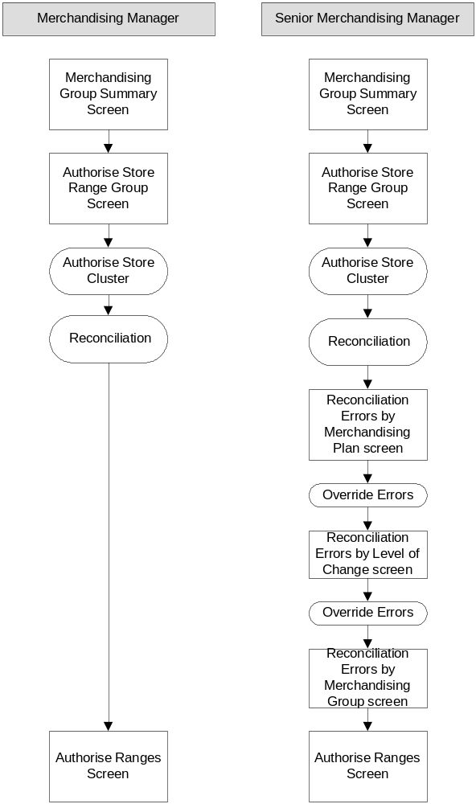
The process and screen flow will vary depending on the merchandising role; Merchandising Managers will elect to authorise and view the reconciliation errors, Senior Merchandising Managers will have the ability to override errors where relevant.

From the Merchandising Group Summary screen Merchandising will select the merchandising group they wish to authorise and choose the “Authorise” option. The Authorise Store Range Group screen will be displayed and they will then select the store clusters they wish to authorise.

Authorise Store Range Group Screen
The purpose of this screen is to allow a number of store clusters to be selected for authorisation.

Authorise Store Range Group

Merchandising Group Code D2E
Merchandising Group Description Milk
Range Effective Date 19/05/2005
Tesco Week No. 16
Range Change Type Refresh
Range Change Id.
Store Range Group | Effective Date | Region  Code | Z | Y | W | V | U |  | T | S | R |  | → | A
England, Wales, Superstores & Extras | 19/05/2005 | A | ✓ |  | ✓ |  |  |  | ✓
Scotland Superstores & Extras | 26/05/2005 | S | ✓ |  | ✓ |  |  |  |  | ✓
UK, Metro, Upmarket | 26/05/2005 | E |  |  |  | ✓ |  |  |  |  | ✓ |  |  | ✓
Key:  = Range received from Ranging System  ✓ = Range selected for authorisation  ✓ = Range already Authorised |  |  |  |  |  |  |  | Authorise |  |  |  | Print

On this screen the following fields will be displayed:
- Merchandising group code and description
- Range effective date and Tesco Week No
- Range Change Type and Id.
For the merchandising group selected, there will be data for one or more store clusters. For each store cluster the following data will be displayed in rows:
- Store range group description
- Store Range Group Effective date (which maybe different from the Range Effective Date)
- Region Code
All valid space breaks will be displayed in columns across the screen. The following measures will be indicated:
- The space breaks for which a range has been received from CRST
- A range has been selected for authorisation
- Ranges that are already authorised

All store clusters will be pre-selected for authorisation; the user will have to option to de-select an entire store cluster and exclude it from the authorisation process.
When one or more store clusters have been selected and the user selects the “Authorise” option on the screen
a reconciliation process will take place for all of the ranges (space breaks) received for the selected store clusters, in addition to those ranges which are expected but have not yet been received from the ranging system (i.e. the supported space breaks).

When the reconciliation process is complete the appropriate screen will be displayed; i.e. the Authorise Ranges screen will be displayed if the user is a Merchandise Manager.
Senior Merchandising Managers will view reconciliation errors via the Reconciliation Errors screens, with the option to override any applicable reconciliation errors.
The screens will be displayed in the following order:
- Reconciliation Errors by Merchandising Plan
- Reconciliation Errors by Level of Change
- Reconciliation Errors by Merchandising Group
Each screen will only be displayed if errors of the relevant type exist for the selected clusters.
When the screens are displayed the following errors may be accepted:
- Product with Warnings
- Products on plan not in range
- Products in range not on plan
- Level Rundown Failures
- Level of Change
If all the errors for a cluster have been accepted then it will be possible to authorise the cluster.

If any of the following reconciliation errors exist for any of the space breaks for a given cluster, that cluster will not be authorised:
- Dummy New Lines on plan
- Dummy New Lines in range
- Unauthorised products in range
- Ranges Not Received from Ranging System
- Sales History Agreed flag still set to N

When the Senior Merchandiser has viewed all the reconciliation errors the Authorise Ranges screen will then be displayed.

Authorise Ranges Screen
This screen will show the clusters ready for authorisation and allow the user to confirm the authorisation.

Authorise Ranges

Merchandising Group Code D2E
Merchandising Group Description Milk
Range Effective Date 19/05/2005
Tesco Week No. 16
Range Change Type Refresh
Range Change Id.
Store Range Group | Effective Date | Region  Code | Z |  | Y | W | V | U |  | T | S | R |  | → | A
England, Wales, Superstores & Extras | 19/05/2005 | A | ✓ |  |  | ✓ |  |  |  | ✓
Scotland Superstores & Extras | 26/05/2005 | S | ✓ |  |  | ✓ |  |  |  |  | ✓
UK, Metro, Upmarket | 26/05/2005 | E |  |  |  |  | ✓ |  |  |  |  | ✓ |  |  | ✓
Key  ✓=Not Authorised Range  ✓=Ranges ready for Authorisation  ✓=Ranges already Authorised |  |  |  | Back to Authorise Store Range Group |  |  |  |  | Send Ranges to Stores |  |  |  | Print

The screen will display the selected store cluster information and identify:
- Ranges that cannot be authorised because they contain reconciliation errors that may not be accepted by the user
- Ranges that have been reconciled and are ready for authorisation; i.e. either they have no reconciliation errors or those that exist have been accepted by the user
- Previously authorised ranges

The user will request authorisation by selecting the “Send Ranges to Stores” option.
A confirmation message will be displayed showing the clusters about to be authorised and the option to Confirm or Cancel.
If the user confirms:
- the range status for the space break will be set to “Authorised”

- The Authorisation Report will be created and saved automatically with a file name in the format “Authorisation Report for <MerchGroupCode> <RangeEventId>.
- If all the space breaks in all the clusters for the range event have been authorised the range status for the merchandising group will be set to “Authorised” and all ranges will available to downstream systems.
- An audit record will be written to record the event/merch group/store cluster/space break/ that has been authorised, when it was authorised and who authorised it and the version number of the range.
- The user will be returned to the Authorise Ranges screen and the range indicators will be updated to show the clusters that have been authorised.
- Authorisation for the selected event/merchandising group will be released for other users.
If the cancel option is selected the user will be taken back to the Authorise Store Range Group screen.

A range may not be selected for authorisation if it has a status of cancelled or if it has not yet been received form the ranging system.
A plan may be authorised with non-ranged objects that are not valid TPNBs, e.g. text boxes placed on the plan to represent space allocated to products that cannot be precisely placed on a plan, such as deli cheese.

If ranges and plans cannot be reconciled, this should not automatically prevent authorisation of the range or plan. (This accommodates the requirement to build plans that have not been ranged in CRST, e.g. dual merchandising of Soft Drinks in Sandwiches merchandising group) | M

Reconciliation differences will be displayed where they exist and the Senior Merchandise Managers will have the option to override some of these errors and continue with authorisation.

A range containing placeholders may not be authorised. | M

The system will check for the existence of placeholders in ranges and merchandise plans. If any exist, the system will automatically withhold the store range group to which it belongs from authorisation.

A range containing products that have a status of unauthorised, suspended or obsolete in CW may not be authorised. | M
A plan containing products that have a status of unauthorised, suspended or obsolete in CW may not be moved to pending and live. | M

The system will check that ranges and merchandise plans contain only products with a product status of “Authorised”. If any exist the system will automatically withhold the store range group to which it belongs from authorisation.

Only ranges for supported space breaks will be authorised. | M

The ranges for supported space breaks will be created in CRST.

Merchandising Managers must have clear visibility of the store clusters and space breaks they are authorising. | M

Merchandise Managers will have update access to all relevant screens in Ranges in Progress (see section 4.5).

Changes to the product content of a merchandise plan cannot be made when a range has been finally authorised. | M

This will be defined in BSD 5b.

Commercial will automatically be alerted when ranges are authorised. | S

This requirement is out of scope for the initial delivery of CRST due to time constraints of the project.
The process will therefore be supported manually. Merchandising will inform Commercial, either verbally or via email, if any ranges have been authorised.

Merchandising should automatically be prompted if a range change has not been authorised by the end of week –5 | S

Prior to the range effective date there will be an indication on the Merchandising Group Summary screen that the merchandising group is due for authorisation, by colour coding the due merchandising group status as red. The alert will occur 2 weeks prior to the authorisation deadline date. As the default for the authorisation deadline will be 4 weeks prior to the range effective date this will normally occur 6 weeks before the range effective date. There will be no automatic alert for this phase of the project, merchandisers are required to visit the screen regularly to check.

Ranges that will not be placed on merchandise plans will not need to be authorised by merchandising. | M

Ranges that do not need to be planned will be flagged as such and will be automatically authorised once they have been submitted from CRST by Commercial.

Authorised ranges must be made available to downstream systems. | M

When the Merchandiser elects to authorise a store cluster and all the necessary checks have been passed a status flag will be set to “Authorised”. When all of the clusters for the merchandising group in the range event have been authorised the status flag will be set to “Authorised”. At that point all the ranges will be passed to the ODS for to allow the propagation of the authorised range to downstream systems.

Maintain Settings
There is currently no requirement to maintain settings within Ranges in Progress.

Audit Trail

Merchandising have a requirement to audit activity within Ranges in Progress | M

An audit trail is required to log:
- The number of times a range has been “sent” or “submitted for authorisation” from CRST to Ranges in Progress
- When a range was authorised and by whom

The following data will be displayed on the audit screen:
- Range change id
- Merchandising group code
- Store range group description
- Space break
- Range Version Number (recorded at space break level)
- Current status of merchandising group/store range group/space break
- New status of merchandising group/store range group/space break
- Name of user that authorised the range
- Date/Time stamp
Audit records will be grouped by merchandising group code/store cluster/space break. Records should be filtered to show data for a selected merchandise group code.
An audit record will be created each time the status of a merchandising group/store cluster/space break changes to “Authorised”. If a merchandising group/store cluster/space is authorised more than once a separate record will be created.

Management Information Reports

Authorisation Report

A management reporting function is required for the range reconciliation. | M

This report will provide a view of any reconciliation errors identified at the point of range authorisation for selected store clusters.
The report will be compiled and saved automatically when the user elects to “Send Ranges to Stores” from the Authorise Ranges screen and will be viewable from the application.
Clusters subsequently selected for authorisation for the same event will be added to the existing report.
If a cluster “failed” the authorisation process initially and is subsequently re-selected for authorisation, the report will be updated with the reconciliation results.

To view the report the “Authorisation Report” option will be selected from the Main Menu. The user will then select the report they wish to view by entering a merchandise group code or a range event id on the Select Authorisation Report screen.

Select Authorisation Report screen

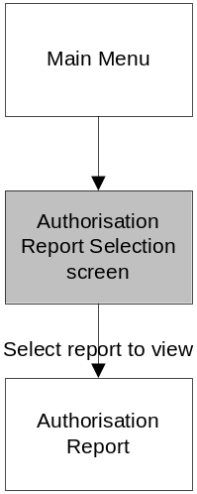
Navigation

Screen Layout

Select Authorisation Report

Search by Merch Group Code
Search By Range Change Id
(List of Available Reports if Merch Group selected )

Authorisation_Report_for_B1B_001
Authorisation_Report_for_B1B_012
Authorisation_Report_for_B1B_025

Field Description

Field | Description
Search by Merch Code | The user may enter a merchandising group code or select from a list of merchandising groups for which reports are available
Search By Range Change Id | The user may enter a Range Event id or select from a list of Range Event ids for which reports are available

Screen Function

When the user first enters the screen only the search boxes will be visible. If the user enters or selects a merch group, a list of reports (file names) available for that merch group will be displayed in descending Range Event Id order. The user will then click on the required report to view.

If the user enters a valid range change id, or selects a range change id from the drop down list the corresponding report will be opened.

Validation and Error handling

If the user inputs an invalid merch group or a merch group for which a report does not exist, an error message will be displayed; “No Authorisation Report available”
If the user inputs an invalid Range Event Id or a Range Event Id for which a report does not exist, an error message will be displayed; “No Authorisation Report available”.

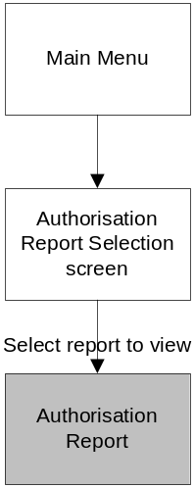
Authorisation Report screen

Navigation

Screen Layout

Authorisation Report for B1B 001
Reconciliation Date:Time
Merchandising Group Code D2E
Merchandising Group Description Milk
Range Effective Date 19/05/2005
Tesco Week No. 16
Range Change Type Refresh
Range Change Id.

Error Summary
Store Range Group | Range Class |  | Error Status
England, Wales, Superstores & Extras | A |  | Errors
England, Wales, Superstores & Extras | D |  | No errors
England, Wales, Superstores & Extras | H |  | Errors
Error Details
Store Range Group | Range Class | Error Type |  | Merch Plan Name |  | TPNB/ Dummy New Line | Error Accepted | Comment | Error Accepted By
 |  |  |  |  |  |  |  |  | Print

Field Descriptions

Field Name | Description
Report Name | Will be displayed at the top of the screen. Report names will be on the format ‘Authorisation Report for <Merch Group Code> <Range Event Id>’
Reconciliation Run Date/Time | The date and time that the reconciliation process was started as part of the authorisation process
Merchandising Group Code and Description | The merchandise group code and description associated with the range event selected on the Merchandise Summary screen
Range Change Id | The range event id of the event selected on the Merchandise Summary screen
Range Effective Date | The range event date for the selected event
Tesco Week No. | The Tesco retail week number corresponding to the range event date
Range Change Type | The description of the range event type, e.g. New Merch Plan, Update, etc
Store Range Groups | The store range group descriptions selected on the Authorise Store Range Group screen
Range Class | The space breaks that have been reconciled during the authorisation process
Range Error Status | If a space break has reconciliation errors that have not been accepted then the text “Errors” will be displayed in this field.  If a space break has no reconciliation errors or errors that have been accepted then the text “No errors” will be displayed in this field
Error Type | The description of the reconciliation error type
Merch Plan Name | The 6 character merch plan name on which the reconciliation error occurred
TPNB/Dummy New Line | The number of the ranging product associated with the error
Error Accepted | A Yes/No indicator
Comments | The Override Comments entered by the user when accepting an error
Error Accepted by: | The name of the user who accepted the error

Screen Function
This screen is read only. The user will have the option to print the report

Validation and Error Handling
N/A

Security/Access

Role  Function | Merchandising Manager | Senior Merchandising Manager | CRST Users | System Administrator
Login | ✓ | ✓ | ✓ | ✓
Select User | ✓* | ✓* |  | ✓*
View Merchandising Group Summary Screen | ✓* | ✓* | ✓* | ✓*
Agree Sales History | ✓ | ✓ |  | ✓
View Range Status | ✓ | ✓ |  | ✓
View/Print Final Authorisation Report | ✓ | ✓ | ✓ | ✓
View Store Range Group Information | ✓ | ✓ | ✓ | ✓
Reconcile Range | ✓ | ✓ | ✓ | ✓
Authorise Range | ✓ | ✓ |  | ✓
View Range Status Summary Screen | ✓ | ✓ |  | ✓
View Range Status Details Screen | ✓ | ✓ |  | ✓
View Store Range Group Summary Screen | ✓ | ✓ | ✓ | ✓
View Product Information | ✓ | ✓ |  | ✓
Send Ranges to Merch Systems | ✓ | ✓ |  | ✓
View Level of Change Screen | ✓ | ✓ |  | ✓
View Product Summary Screen | ✓ | ✓ |  | ✓
View Product Detail Screen | ✓ | ✓ |  | ✓
View Product Matrix Screen | ✓ | ✓ |  | ✓
View Product Sales Screen | ✓ | ✓ |  | ✓
View Reconcile Store Range Group Screen | ✓ | ✓ | ✓ | ✓
Reconcile Store Range Groups | ✓ | ✓ | ✓ | ✓
View Reconciliation Error Summary Screen | ✓ | ✓ | ✓ | ✓
View Reconciliation Errors by Merchandise Group Screen | ✓ | ✓ |  | ✓
View Reconciliation Errors by Level of Change | ✓ | ✓ |  | ✓
Accept Level of Change Reconciliation Errors |  | ✓ |  | ✓
View Reconciliation Errors by Merchandise Plan | ✓ | ✓ | ✓ | ✓
Accept Merchandise Plans Reconciliation Errors |  | ✓ |  | ✓
View Reconciliation Errors by Product | ✓ | ✓ | ✓ | ✓
View Authorise Store Range Groups Screen | ✓ | ✓ |  | ✓
Select Store Range Groups for Authorisation | ✓ | ✓ |  | ✓
View Authorise Range Screen | ✓ | ✓ |  | ✓
Confirm Authorise Ranges | ✓ | ✓ |  | ✓
View Authorisation Report Screen | ✓ | ✓ |  | ✓
Print Authorisation Report | ✓ | ✓ |  | ✓
View Select  Authorisation Report screen | ✓ | ✓ |  | ✓
View Audit Trail |  | ✓ |  | ✓
Maintain Users |  |  |  | ✓

* Access to data will be restricted in some cases, determined by a hierarchy of responsibility described below.
Merchandising hierarchy:
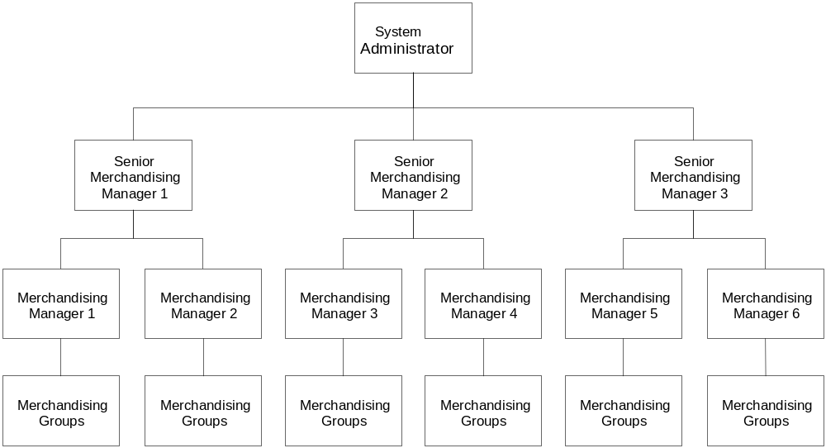

Merchandising Managers are responsible for maintaining multiple merchandising groups and report to one Senior Merchandising Manager.
Relationships will be maintained within the system to link merchandise groups to Merchandise Managers and Merchandise Managers to Senior Merchandise Managers.
Merchandising Managers will have permission to view and process data for all the merchandising groups for which all the Merchandising Managers are responsible within their Senior Merchandising hierarchy. This data will be filtered so that the default view is those merchandising groups to which they are linked, with the option to process others within their hierarchy, by using the “Select User” option. For example, on entry to the system, they will see their own merchandising groups but can select another user reporting to Senior Merchandising Manager 1, Merchandising Manager 2, to view and process the merchandising groups to which he is linked. Merchandise Managers 1&2 will not be able to select any other users.
Senior Merchandising Managers will have permission to view and process data for all the merchandising groups but they will be filtered so that the default view is those merchandising groups for which their Merchandising Managers are responsible. There will be an option to process other merchandising groups linked to other users within all other hierarchies.
Merchandise Systems Managers will have the permission to view and process all merchandising groups, the default being all merchandising groups, with the ability to filter by any user.
CRST Users will have the permission to view only those merchandising groups for which they are responsible for ranging. The Commercial security structure is defined in BSD 4.
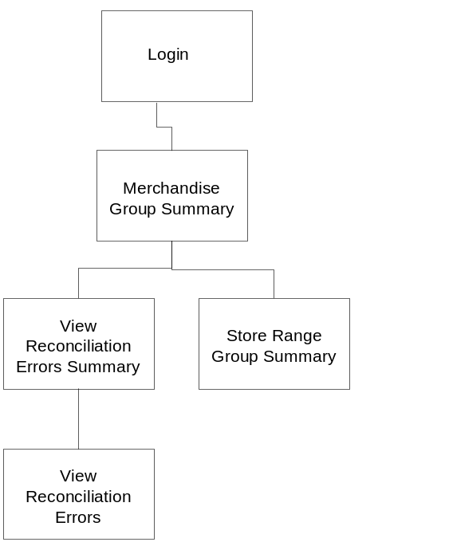The diagram below shows the screens that CRST Users will have access to.

Appendices

Range Status
Merchandising group statuses will be derived from the combination of statuses of individual space breaks as shown in the table below. E.g. if all of the supported space breaks for all of the store range groups have a status of Authorised the merchandising group status would be displayed as Authorised.
Merchandising Group Range status fields will be colour coded, depending on the status of the individual space breaks, and also defined in the table below.
Combinations of Range (Space Break) Statuses for a given merchandising group |  |  |  | Derived MG Status | MG status Colour | Comments
*Waiting |  |  |  | Not Received from Ranging System | Blank | Changing colour coding to Red 2weeks before the Authorisation Deadline
*Waiting | Received |  |  | In Progress | Red
*Waiting |  | Sent |  | In Progress | Red
*Waiting |  |  | Authorised | In Progress | Amber | Changing colour coding to Red 2weeks before the Authorisation Deadline
*Waiting | Received | Sent |  | In Progress | Red
*Waiting | Received |  | Authorised | In Progress | Red
*Waiting |  | Sent | Authorised | In Progress | Red
*Waiting | Received | Sent | Authorised | In Progress | Red
 | Received |  |  | In Progress | Red
 | Received | Sent |  | In Progress | Red
 | Received |  | Authorised | In Progress | Red
 | Received | Sent | Authorised | In Progress | Red
 |  | Sent |  | In Progress | Red
 |  | Sent | Authorised | In Progress | Red
 |  |  | Authorised | Authorised | Green
 |  |  | Cancelled | Cancelled | Blank

* N.B. There is no space break status value of “Waiting”. A space break that is supported, and for which a range will be created but has not yet been received from CRST, is deemed to be “waiting” but there will be no record in the range status table for that space break.

Document Control

Project: | Commercial Range Support Tool
Document Title: | Merchandising Ranges - Business System Design
Document Location: | Ranging (CRST) Workroom
Distribution: | Ranges in Progress Development Team  Testing Team

Change Record

Date | Author | Change Description | Version
31/03/2005 | Sue Leach | Initial Draft | 0.1
04/04/2005 | Sue Leach | Initial draft including screen designs | 0.2
08/04/2005 | Sue Leach | Feedback from review with GT&A. Issued for IT team review | 0.3
12/04/2005 | Sue Leach | Revised following team review. | 0.4
28/04/2005 | Sue Leach | Revised following comments from team review. Updated following requirement changes. Issued to Amanda Sawkins/Meryl Hanlon for review. | 0.5
05/05/2005 | Sue Leach | Issued to John Wootton for Business review | 0.6
24/05/2005 | Sue Leach | Feedback and design changes following Business Review. Issued for second Business review | 0.7
26/05/2005 | Sue Leach | Changes following second Business Review. Issued for final review prior to sign off | 0.8
15/06/2005 | Sue Leach | Issued for business sign off | 1.0
30/06/2005 | Sue Leach | Final Version | 2.0
06/07/05 | Sue Leach | See change log for amendments. Version signed off for development | 2.1
05/01/2006 | Sue Leach | Removed sections pertaining to withholding ranges as this is no longer a business requirement.  Removed sections for maintaining level of change as this will be developed as part of the Event Management system.  Updated with minor design amendments following development. See change log for details.  Not issued for review or sign off. | 3.0

Associated Documents

Document Title: | Location:
BRD 5 Merchandising Ranges for CRST
BSD4 Ranges in Progress

